

Welcome to week 9! Hopefully everything has calmed down a bit for you all, with your lecturers giving you more of a break, and assessments already handed in, but if not, then Canberra is sure to give you a break! Because it’s dead quiet…..There is literally nothing on this week in Canberra, so we at Bruce have decided to give you some things to do. Rejoice!

*Doing it for Bill since 2014*

THE BRUCE BILLITIN

**ISSUE 10: Tuesday 26th April – Monday 2nd May**

*Doing it for Bill since 2014*

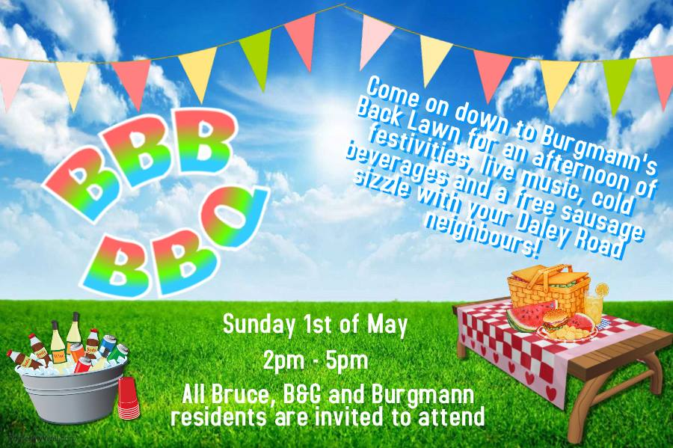

INTERNATIONAL DANCE DAY IN NEWACTON  
**29th April New Acton Precinct**

Come celebrate international Dane day in the newActon precinct with two captivating performances which comment on our society and what it means to be human.

COLLECTOR VILLAGE PUMPKIN FESTIVAL

**1st May 2016 in Collector Village**

For those willing to go the extra mile (35.98 to be exact) this excellent festival is for you! One of the largest community events in the region, with over 120 stall holders, this is sure to be for those who want to get a taste of a traditional country fair (sort of) on our doorstep.

GLOBAL PROGRAMS : Exchange Information session  
**1-2pm 28th April Manning Clark T3**

Are you interested in going on exchange? Do you want to see the world? Then this information session is for you, as if you are interested in going on exchange during Semester 1 2017, then you must attend an information session during March/April!

WHY WE NEED BATMAN: The politics, philosophy and popularity of the caped crusader  
**6-6:45pm May 5th Coombs Lecture Theatre**

While this isn’t in the week of this issue, this lecture is about batman and hence you guys need to be pumped and schedule everything around it so you can make it. Because Batman is cool, and Kim Huynh, an IR lecturer at ANU will tell you why.

BRUCE HALL: An interactive Guide

BBB BBQ

**Sunday 1st May 2pm-5pm Burgmann**

That’s right my dear brucies, we have an event for you in which you may…wait for it…. Have to deal with people outside of Bruce. It’ll be tough, but we recommend you do it, as there will be food and drink aplenty, as well as an opportunity to feel pity for other colleges.

YOU, YOUR FRIEND & MENTAL HEALTH  
**8pm 3rd May BN Room**

ANU counselling has kindly offered to send someone down to talk to us about those difficult conversations you will have with your friends who are dealing with mental health issues. More details about this event will be released shortly, so please keep your eyes peeled, as this is something which is important for all of us.

SPORT

We have multiple sports games throughout this next week, all of which will be posted in tonight’s minutes or on Banter. Please show your support for our hard-working teams.

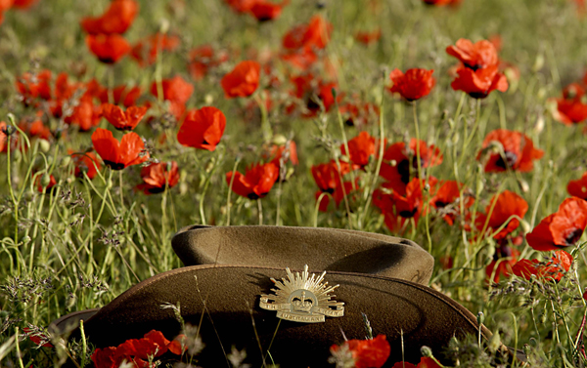

I did not have sexual relations with that women – *Bill Clinton*



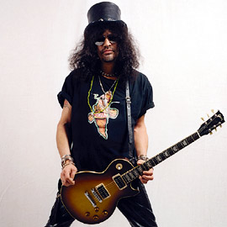

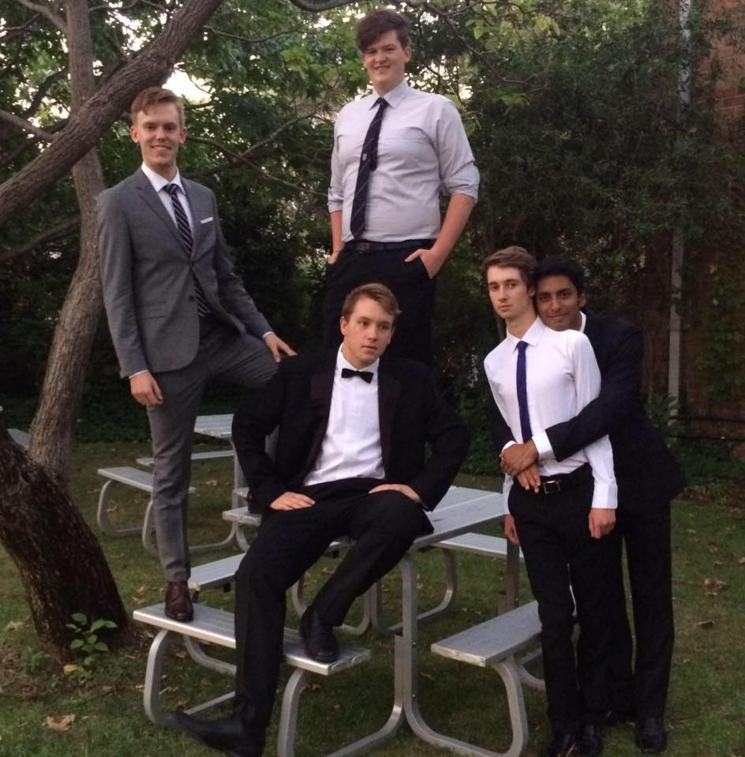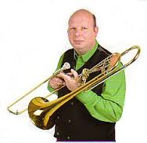

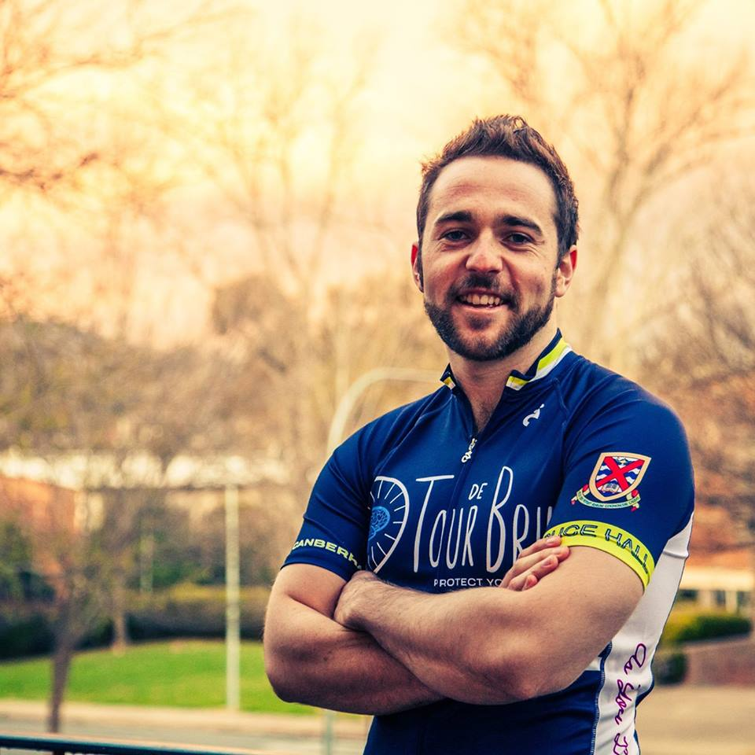

TRIVIA

1. What famous painter has a last name similar to a country in 5. What is the world’s largest ocean?

Western Europe? 6. What African country was Freddie Mercury born in?

2. What is the name of the band responsible for the hit ‘Parlez 7. What was the first capital city of the United States?  
 vous francais?’? 8. In what year did the French Revolution begin?

3. What popular beverage once contained cocaine? 9. Who wrote the literary classic ‘Wuthering Heights’?

4. Who wrote the seminal political tome ‘The Prince’? 10. On what continent would you not find bees?

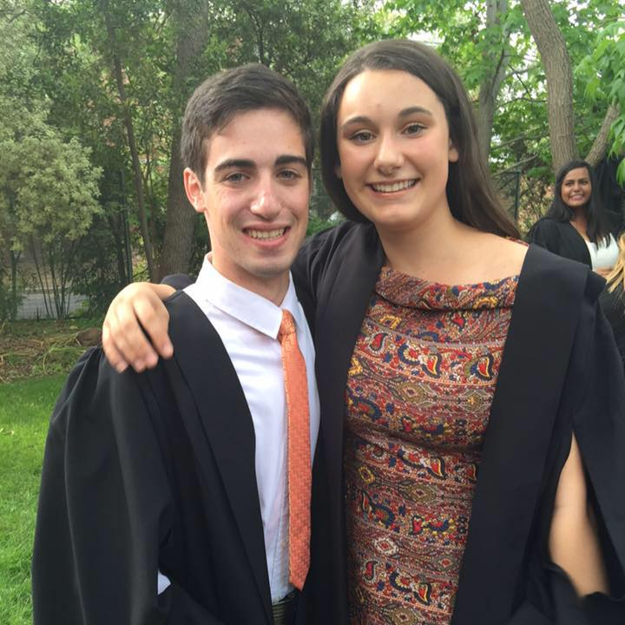



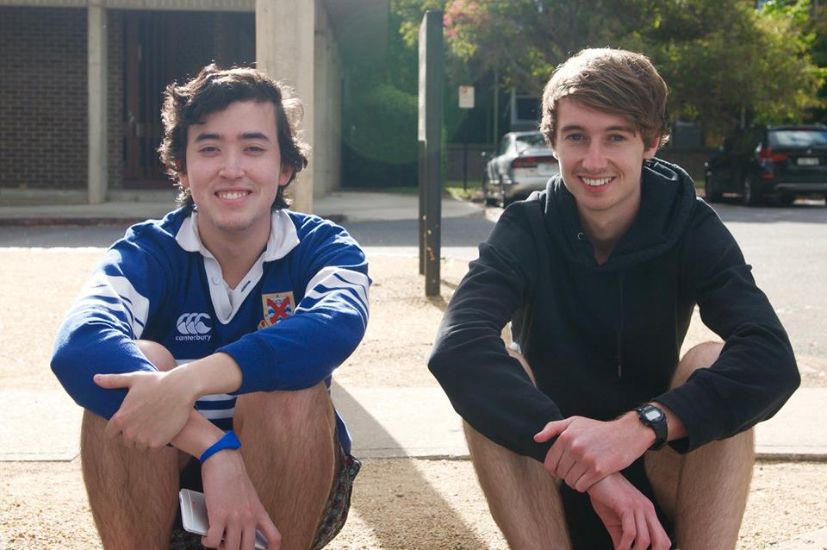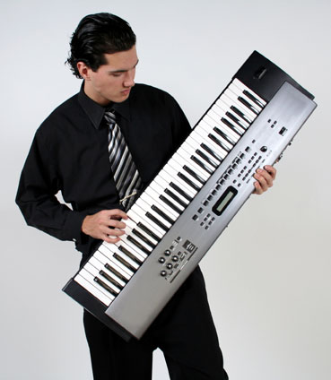

BIG NIGHT OUT

Enjoy our band at Big Night in?

Want to see more?

THEN COME TO BIG NIGHT OUT!!!

Its on this Thursday at 7pm, with the gates opening at 6:30pm, and lockout at 9:30. You need to bring along your Uni ID to get in, as well as cash for food and drinks (and a real ID if you want dranks). Tickets are available online/in Union court from 10-2 this week.

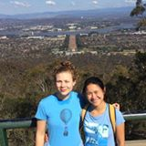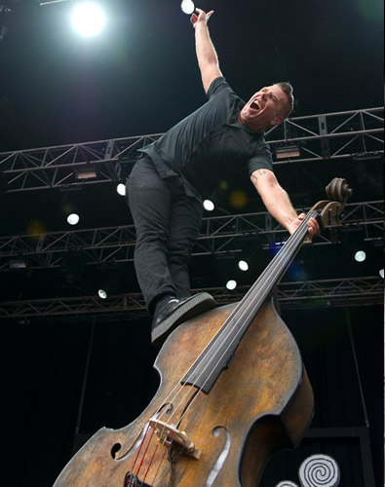

1. Roy Lichtenstein, 2. Lichtenstein, 3. Coca Cola, 4. Machiavelli, 5. The Pacific Ocean, 6. Tanzania,7. Philadelphia, 8. 1789, 9. Emily Bronte, 10. Antarctica

